1.  Go to episode: LGCD (underground copper mining)  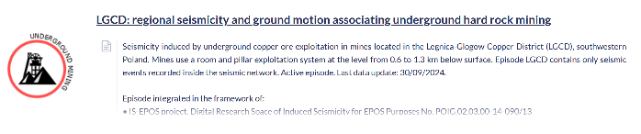 | 6.  Fill the essential inputs with necessary data.  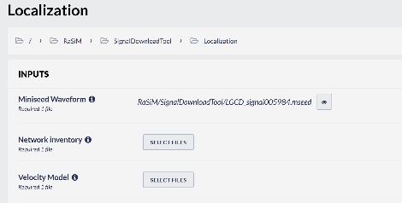
2.  Find Catalog and add to your Workspace  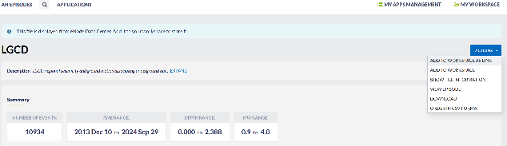 | 7.  Pick your seismograms with P-waves arrivals (try to use only EHZ component!)  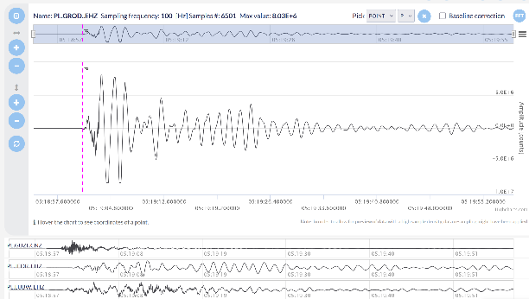
3.  Use Seismic Download Tool to get the Miniseed Signal  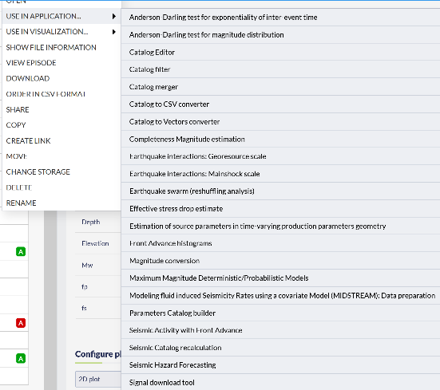 | 8.  Put initial location either from Catalog or as: 51.51 16.16 which is middle point of the network in LGCD Episode. Event description is up to your choice.
4.  Use Miniseed file in TRMLOC app.  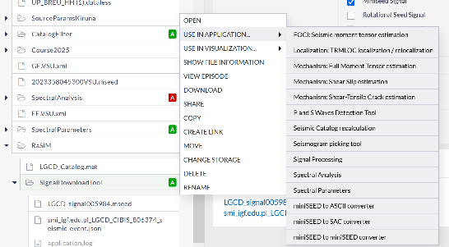 | 9.  Try to be with your location (assuming Average solution) as much as possible close to the original one.  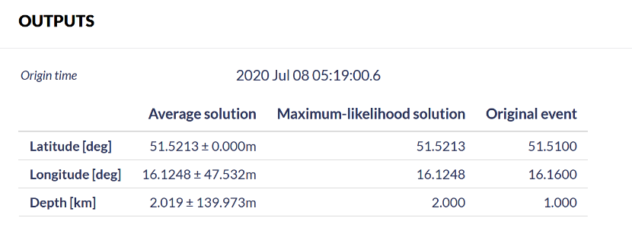
5.  Add velocity model and station metadata into your Workspace - they are available in Episode LGCD: Velocity Model and Seismic Network. | 10.  Done!  Congratulation!

